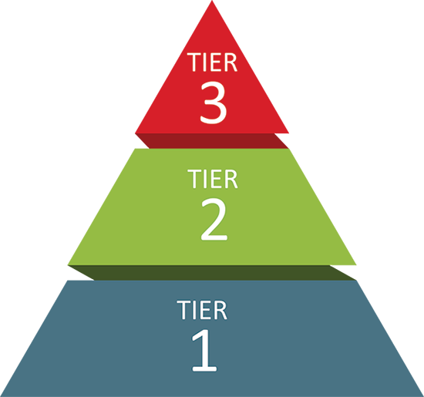
TIERED SYSTEM OF SUPPORTS
STEM at Blodgett Middle School
Tier 1
Universal Supports
Schoolwide and classroom practices that promote the development and practice of pro-social behaviors, self-discipline, habits of learning, and healthy well-being.
Ronald Cortina
Dignity Act Coordinator
Michele Walker
School Counselor
Jordan Johnson
Program Aide, Office of Family Engagement
Ronal Cortina/Paul Crisafulli/Tavon Goddard
Dean of Students
Tier 2
Targeted Supports
Coordinated supports that match students’ social, emotional, and mental health needs to address the root cause of an issue.
Dajvan Coleman
PromiseZone Specialists
Dr. Ada Hernandez
Special Education Liaison
Marimar Nunez
Section 504 Administrator
Michelle Walker
Section 504 Liaison
Patrice Johnson/Yaneta Mathis
Social Workers
Tier 3
Intensive Supports
Intensive, specialized support.
Katie Goodfellow
Mental Health Clinician, Liberty Resources
Wilnisha Sholtz
Family Support for Student Success, School Support
Tiffany Pacheco
Access School Liaisons
Kayla Gallagher
School Psychologist
Dominic Range/Brenlys Lopez-Camacho
Hillside Youth Advocates
Shaniyah Love
Peaceful Schools
Destani Jones/Chris Gilles
ONE MIC

