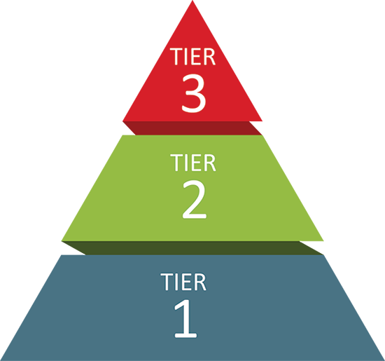
Roberts PK-8 School
Tier 1
Universal Supports
Schoolwide and classroom practices that promote the development and practice of pro-social behaviors, self-discipline, habits of learning, and healthy well-being.
Shaena Brasz/Sharon Archer
Dignity Act Coordinator
Leigh Sexton
Dignity Act Coordinator
Ava Darisaw/Ed Mitchell
Student Support Center Staff
Murjahi Ramazani/TBD
School Counselor
Tier 2
Targeted Supports
Coordinated supports that match students’ social, emotional, and mental health needs to address the root cause of an issue.
Kalin Douglas
PromiseZone Specialist
Jill Sincebaugh
Special Education Liaison
Lindsay Thompson
Section 504 Administrator
Renee Curkendall
Section 504 Liaison
Leigh Sexton/Amy Phinney
Social Worker
Kelley Corbett
Social Worker Assistant
Tier 3
Intensive Supports
Intensive, specialized support.
Anna Axford
Mental Health Clinician, Liberty
Jackie Guglielmo
Access School Liaison
Carl Mannino
School Psychologist
Johnny Bennett
Hillside Youth Advocate
Maggie O’Connor
Contact
TIERED SYSTEM OF SUPPORTS

